Education Resources

Wiston Primary School
Handbook 2016

WISTON PRIMARY SCHOOL

HANDBOOK 2020

Contents

- Introduction
- About our School
- Parental Involvement
- School Ethos
- The Curriculum
- Assessment and Tracking Progress
- Reporting
- Transitions
- Support for Pupils (Additional Support Needs)
- School Improvement
- School Policies and Practical Information

If you need this information in another language or format please contact us to discuss how we can best meet your needs please contact us: 0303 123 1023 or email education@southlanarkshire.gov.uk

Wiston Primary School
Wiston
Biggar
ML12 6HT

The warmest of welcomes to Wiston Primary School. I hope you will find our School Handbook interesting and informative.

At Wiston we strive to promote positive relationships with our parents and the community. Our whole staff is committed to providing the highest quality of educational experiences for our pupils. I do hope that you find us an open and approachable team.

All members of staff have high expectations of our pupils in attainment as well as in behaviour and attitude. Together, in partnership with you, we will work hard to fulfil their potential.

Please be asured that no worry affecting your child is too small to share with us. If you have any concerns do not hesitate to get in touch.

While a handbook cannot fully convey the atmosphere of Wiston, I hope it will give you a flavour of our school. Should you have any questions or you would like to come and see around our school or need more information we will be proud to show you around.

Kindest regards,

Elma McGregor
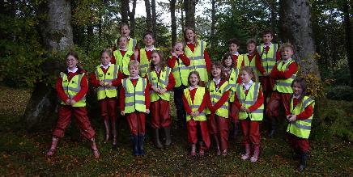
Head Teacher
1) Introduction

Wiston Primary School is one of 124 South Lanarkshire Primary Schools. It is part of the 14 schools that make up Biggar Learning Community.

South Lanarkshire Council is the fifth largest authority in Scotland. It covers the following main areas; Clydesdale in the south which features extensive rural areas, Cambuslang, Rutherglen, Blantyre and Uddingston to the north as well as the towns of East Kilbride and Hamilton.

The Council’s Plan Connect sets out the Council’s vision which is, “to improve the quality of life for all within South Lanarkshire”.

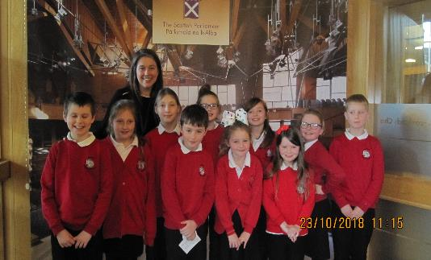
For Education Resources this means delivering services of the highest quality as well as striving to narrow the gap. It is about continually improving the services for everyone at the same time as giving priority to children, young people, families and communities in most need. The priorities for schools and services are set out in the Education Resources Plan which confirms the commitment to provide better learning opportunities and outcomes for children and young people.
At Wiston, our children are at the heart of everything we do. We strive to create a culture and environment which inspires them to be the very best they can be. We have the highest expectations of achievement and behaviour and offer a nurturing and supportive environment where everyone feels valued. We place great importance on our close working links with our parents and the wider community

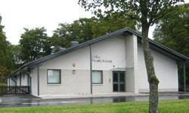

2) Our School

Wiston Primary School
Millrigg Road
Wiston
BIGGAR
ML12 6HT

Phone: 01899 850634
Fax: 01899 850298

Email: Office:
office@wiston-pri.s-lanark.sch.uk
Head Teacher:gw14wistonpsht@glow.sch.uk

School Website: www.wiston-pri.s-lanark.sch.uk

Present Role: 18

Stages Covered: Primary 1 to Primary 7

Wiston Primary is a non-denominational, co-educational school.

Staff

Head Teacher Mrs Elma McGregor
Principal Teacher Mr Martyn O’Donnell (P1-4 teacher)
Class Teacher Miss Jodie Logan (P5-7 teacher)
Class Contact Cover Mrs Laura Forde/Ms Adrienne Nelis
Support Staff Mrs Sarah Alcock
Mrs Alison Littlejohn
Caretaker/School Cook Mrs Sara Weardon
Music Tutor Mr Richard Fraser
Support for Learning Mrs Hazel Leggate
School Chaplain Dr. Nikki Macdonald
Quality Link Officer Mrs Lisa Quinn

Attendance

It is important for the school to work with parents in encouraging all children to attend school. All absences from school are required by law to be recorded. Absences will normally fall under two categories – authorised or unauthorised absence. In cases where your child is unable to attend school parents are asked to:

- Inform the school by letter or phone, if your child is likely to be absent for some time
- Notify the school first thing in the morning when your child is going to be absent. Let the school know the likely date of return and keep us informed if the date changes.

Please inform us of any change to the following:
- home phone number
- mobile phone number
- emergency contact details

If you have any concerns regarding any aspect of your child’s education please do not hesitate to contact us and we will work together to resolve it.

The Head Teacher can be contacted at gw14wistonpsht@glow.sch.uk
- Contact Education Resources: Education Resources, Council Offices, Almada Street, Hamilton, ML3 0AE Tel: 0303 123 1023.

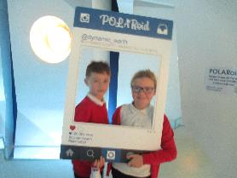

3) Parental Involvement

South Lanarkshire Council recognises the importance of parents as partners in the education of their child and has published a strategy entitled, ‘Making a difference – working together to support children’s learning’. This is available from the Council’s website: www.southlanarkshire.gov.uk

Parents, carers and family members are by far the most important influences on children’s lives. Children between the ages of 5 and 16 children spend only 15% of their time in school! Research shows that when parents are involved in their child’s learning, children do better at school and throughout life. Parental involvement can take different forms but we hope you share the same aims and agree that by working together we can be partners in supporting children’s learning.

As a parent/carer we want you to be:

- Welcomed and given an opportunity to be involved in the life of the school;
- Fully informed about your child’s learning;
- Encouraged to make an active contribution to your child’s learning;
- Able to support learning at home;
- Encouraged to express your views and involved in forums and discussions on education related

Parent Council

Wiston Primary has a very active and enthusiastic Parent Council. The Chairperson is Mrs Lesley Anne McCaskie.

Some of the roles of our Parent Council:

- Supporting the work of the school;
- Gathering and representing parents’ views to the Head Teacher, education authority and HMIe;
- Promoting contact between the school, parents, children and young people and the local community;
- Fundraising;
- Involvement in the appointment of senior school staff.

The school also benefits from a core group of parent and carer helpers who assist throughout the year. All helpers on school trips and educational visits are PVG checked for suitability in accompanying children. Why not become involved yourself? If you would like more information please contact the school.

4) School Ethos

Our school is situated in the heart of the village of Wiston at the foot of Tinto Hill. It was built in 2010 and is a bright inspiring building to meet the needs of the twenty first century.
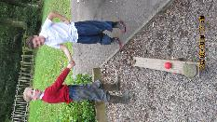
As well as state of the art indoors, it has access to outstanding outdoor learning facilities both within the school grounds and next door at Wiston Lodge. Recently working alongside the Wiston Community Enhancement Groups we obtained funding to develop our school playground further.

Wiston is part of a shared headship with Libberton Primary. Both schools work together on a regular basis which has great benefits for the children both educationally and socially.

Our Vision for Wiston Primary:

At Wiston our children are at the heart of everything we do. We strive to create a culture and environment which inspires them to be the very best they can be. We have the highest expectations of achievement and behaviour and offer a nurturing and supportive environment where everyone feels valued. We place great importance on our close working links with our parents and the wider community.

VALUES : At Wiston we value the qualities of respect, achievement, enjoyment and responsibility

AIMS

Our aim is for all children to be given the opportunity to develop into positive, healthy young adults and to make the most of their educational opportunities.

We, as a staff, work together to provide a caring, stimulating and positive environment where the quality of teaching and learning encourages children to reach their full potential as successful learners, responsible citizens, effective contributors and confident individuals.

Good regular attendance and time-keeping, polite manners, respect for others and a commitment to performing to the best of one’s ability are all encouraged.

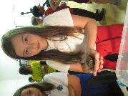
We strive to create an atmosphere which encourages and rewards positive attitudes and behaviour, which celebrates success and stimulates interest and enthusiasm for life-long learning. We are justifiably proud of our high standard of behaviour, involvement in the community and achievements of individuals as well as a school generally.

‘All children are enthusiastic in their learning. They are motivated, purposeful and well behaved. Children recognise that staff know them well and that they are valued. They work very well independently, in pairs, and together in small groups. Children are demonstrating good skills as learners through the use of peer- and self-assessment.’
HMIe Report Wiston Primary

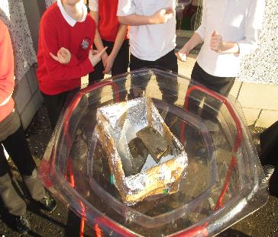

5) The Curriculum

Curriculum for Excellence

Bringing learning to life and life to learning
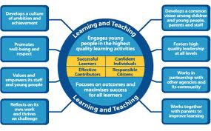

Curriculum for Excellence is the name given to the new curriculum in Scotland for all children and young people aged 3-18. It is a forward; looking, coherent, more flexible and enriched curriculum that provides young people with the knowledge, skills and attributes they will need if they are to flourish in life, learning and work, now and in the future.

The curriculum includes all of the experiences that are planned for children and young people to support the development of their skills, wherever they are being educated, for example in the family and community, pre-school centre, nursery and school. This broad, general education will allow them to become successful learners, confident individuals, responsible citizens and effective contributors to life in the 21st century.

I feel safe and I can talk to the staff if I need help or I am upset
Pupil

In taking this forward our school will work closely with South Lanarkshire Education Resources and other services to enable Curriculum for Excellence to be fully embedded, ensuring the best possible education for all children and young people. We wish you to feel confident that your child is encouraged and supported to develop their literacy, numeracy and other skills whilst they attend our school.

Curriculum for Excellence is about a great deal more than just what Children learn; it is perhaps even more about how children learn. Curriculum for Excellence recognises that the best learning comes about when children are happy, safe and secure.

At Wiston Primary we believe they learn best when:

- they can be involved in deciding what to do, sharing expectations and standards, taking responsibility for their learning and discussing the success criteria
- they are engaged and active, involved in discussing, explaining, interacting, investigating, exploring, creating, collaborating, evaluating and analysing.
- there is a good mix of activities: some involving discussion and working with others, and some quietly alone
- they can see how their learning will help them achieve their goals
- they are able to reflect on their learning and decide the next steps to improve their own learning as part of personal learning planning
- the activities are stimulating, and give a sense of achievement
- they are set challenging goals
- they receive timely and accurate feedback

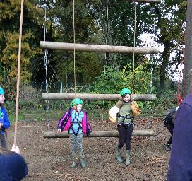
The curriculum areas are as follows:

- Expressive arts (Art, Music, Dance, Drama)
- Languages and literacy
- Health and wellbeing (including P.E.)
- Mathematics and numeracy
- Religious and moral education
- Science
- Social studies
- Technologies

Modern Foreign Language
Primary 1-7 receive tuition in French and Primary 5-7 are learning Spanish too.

ICT
ICT permeates all aspects of the curriculum. Children have access to networked PCs, iPads and an Interactive Whiteboard

Outdoor Learning
At Wiston we are proud of our amazing surroundings and we are committed to use it to motivate and challenge our children.

Extra curricular Activities
Wiston Primary School offer extra curricular activities throughout the year both at lunchtime and after school. They are supervised/ run by teachers/specialists/ older pupils and parent volunteers. Already this session we have had football and basketball. We are keen to hear from anyone who has a skill they would like to share with the children. (All adults must hold a valid PVG certificate)

Our learning and teaching activities are based on the outcomes and experiences in the guidelines that all schools have for Curriculum for Excellence.

Level Stage
Early The pre-school years and Primary 1 or later for some.

First To the end of Primary 4, but earlier or later for some.

Second To the end of Primary 7, but earlier or later for some.

If you want to know more about Curriculum for Excellence, please visit website http://www.educationscotland.gov.uk/thecurriculum/ or www.parentzonescotland.gov.uk.

Spiritual, social, moral and cultural values

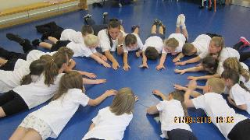
At Wiston Primary School we aim to create an environment where our pupils appreciate values such as honesty, liberty, justice, fairness and concern for others. The children will be encouraged to develop a respect for other peoples’ ideas, values, customs and beliefs, both within their community and the wider world.

Rights of Parents / Carers
Scottish Government Ministers consider that religious observance complements religious education and is an important contribution to pupils’ development. It should also have a role in promoting the ethos of a school by bringing pupils together and creating a sense of community.

There is a statutory provision for parents to withdraw children from participation in religious observance. This right of parents’ wishes will be respected.
Where a child is withdrawn from religious observance, schools will make suitable arrangements for the child to participate in a worthwhile alternative activity.

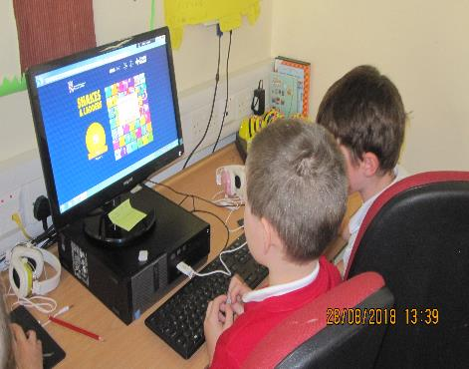
I like that my children are thriving and growing into confident little people. My children enjoy learning and look forward to coming to school every day.
Parent

Health and Wellbeing Relationships, Sexual Health and Parenthood (RSHP)

Our local authority is committed to the provision of quality sex education in accordance with
National Guidelines. It forms a key element of personal, social and health education in schools
and is an important part of children’s preparations for adult life. The purpose of RSHP work is to
provide knowledge and understanding of the nature of sexuality and the processes of human
reproduction within the context of relationships based on love and respect. All parents have the
right to withdraw their children from RSHP lessons. Please notify the school in writing. If you wish
to view the materials please contact the school.

The RSHP programme for the pupils will comprise:

Early years of primary school
· Awareness of the way bodies grow and change
· Uniqueness of their body
· Where living things come from
Family and special people who care for them

Middle stages
· Exploring changes in the body
· How human life begins
· Being part of a family
· Dealing with bullying situations

Upper stages
· Physical and Emotional changes at puberty
· Body image and self worth
· Understanding of own developing sexuality
· Developing an awareness of gender identity
· Changing nature of friendship
· Dealing with sexual feelings
· Menstruation, pregnancy and birth

Active learning at Wiston

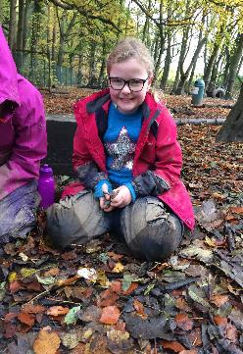

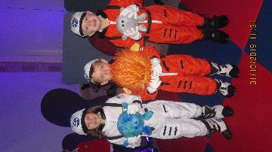

Equalities

Integral to this guidance is the principle of mutual respect. The diversity of belief and tradition provides an ideal context in which pupils can learn about, and so learn from, what is important in the lives of themselves and others. South Lanarkshire’s guidance recognises and welcomes diversity and promotes respectful understanding.

Parents may request that their children be permitted to be absent in order to celebrate recognised religious events. Advance notice should be provided to the school when children will be absent. Appropriate requests will be granted and the pupil noted as an authorised absentee in the register.

Wiston encourages independence and responsibility for actions
Parent
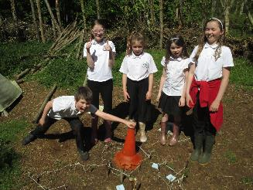

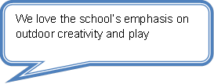

6) Assessment and Tracking Progress

Assessment is a way of supporting learning. It helps teachers, learners, parents and others to understand the depth and breadth of learning undertaken so that progress and next steps can be discussed and planned.

Your child’s progress is not only based on ‘tests’ but on the learning that takes place within the classroom and in different settings out with the classroom.

Curriculum for Excellence has improved Assessment in the following ways:

- A better connected assessment system with smoother links through pre-school, primary, secondary school and college.
- More ways of assessing progress to support learning and more flexibility to meet learners' individual needs.
- By introducing a profile of our children’s’ achievements this will give a clear statement of the achievements they have made and the skills they have developed at these crucial times in their lives. At Wiston each child has a Learning Journey folder which progresses with them from Primary 1 and becomes a record of their attainment and achievement both in and out of school.

Evidence of children and young people's progress and achievements will come from day to day learning and through the things they may write, say, make or do. For example evidence may emerge as a result of children and young people taking part in a presentation, discussion, performance or practical investigation. Evidence could also be a drawing, report, or piece of art work that they have produced. Evidence may be captured as a photograph, video or audio clip as part of a particular learning experience.

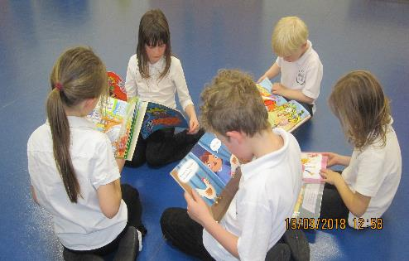

7) Reporting

Reporting will be ongoing and comprise of a range of activities which can include children presenting their learning, newsletters, and ongoing oral discussions.

We will provide parents with reports so that you can see what your child is doing and how they are progressing. In addition, there will be parents’ meetings which offer you the opportunity to discuss how your child’s progressing and how you can contact the school if you wish further information. The school will offer you an appointment time so that you can visit in person to discuss your child’s education.

Our ‘pupil reports’ will help you to get to know more about the curriculum which each child follows and will describe their strengths, achievements and areas for development so you know what encouragement and support you can give.
We welcome any comments or additional information from parents to help us provide the best possible education for your child.

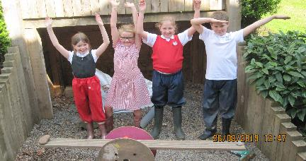
8) Transitions
My child has been welcomed, accepted and allowed to develop at her pace since day one. She achieves and experiences success every day and as a result has been allowed to develop into a confident, happy individual while at school – this would not have happened at every school. Parent

I like it that I have friends and I learn new stuff
Pupil

Transitions are the moves children and young people make from home to nursery, from stage to stage and through Curriculum for Excellence levels and on to Secondary School. Transitions are part of everyone’s life.

When transitions work well they help children and young people to develop confidence and acquire skills to manage future changes in their lives.

The vast majority of children and young people look forward to moving on in learning and in life. For some children transitions can be challenging and support from parents and staff at school can help the transitions go more smoothly.

Some children may need particular help perhaps including some other agencies to ensure that they feel confident about the transitions. It helps children at all transitions if staff and parents:

- Talk with them about what is going to happen
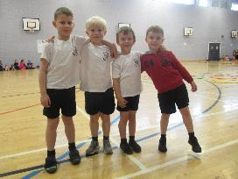
- Encourage them to talk about any concerns or anxieties
- Listen carefully to their concerns and consider sharing them with other relevant people
- Help them become familiar with the new setting and what will be expected of them
Scottish Government Curriculum for Excellence Fact-file – Transitions June 2011

From nursery to primary
Children come to Wiston Primary from various council and private nurseries in the area. Our aims are

- To ensure a smooth transition for each child through effective communications between children, parents and staff.
- To create a positive and supportive climate for the child and the parents/carers in the pre-school setting and in the school.
- To develop a shared continuity in learning between pre-school and primary education through the transition record and any individual educational programmes.

To facilitate this:
- Each child will have the opportunity to visit the school and meet the other children and staff.
- P1 and nursery staff will have opportunities to visit the other setting to meet and discuss the children
- Each child’s nursery report and records will be sent to the school
- Any appropriate information from other agencies that will be helpful in transition, will be sent onto school
- When a child has a CSP or ASP a review meeting will be held at Nursery prior to entry to school. This will include staff from both settings, parents and other relevant agencies

From primary to secondary
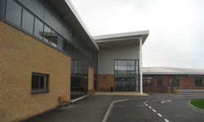
The local high school for Wiston Primary is
Biggar High School
Market Road
Biggar
ML12 6AG
Biggar High School
Phone 01899 222050

Email office@biggar.s-lanark.sch.uk
Website: www.biggar.s-lanark.sch.uk

Pupils normally transfer from primary to secondary school between the ages of 11½ and 12½, so that they will have the opportunity to complete at least 4 years of secondary education.

Arrangements are made by the school to transfer children to the associated secondary school as determined by their home address. Parents of P7 children will be informed of the transfer arrangements made for their child to attend secondary school.

We will also provide you with information at this time and on events designed to let P7 children visit the secondary school, meet up with other P7 children from other schools so that the transition period is as smooth as possible.

Normally children attend the school in their catchment area. However, there are times when parents may wish their children to go to other schools. If you wish your child to go to another school then you may make what is known as a ‘placing request’. If you live in South Lanarkshire and decide to submit a ‘placing request’, we are unable to reserve a place in your catchment school until the Council have made a decision on the ‘placing request’. Please note if your ‘placing request’ application is unsuccessful and all places at your catchment school are filled you will be offered a place at the next nearest appropriate South Lanarkshire School.

Please note that if an application for a ‘placing request’ is successful then school transport is not provided.

If you move out with your catchment primary school a ‘request to remain form’ must be completed and this may affect your right to transfer to the associated Secondary School. Please note the secondary school is determined by the pupil’s permanent home address and chosen denomination. If you require further information, please contact Education Support Services on 0303 123 1023

Transition opportunities with Biggar High School are strong. Throughout the session Primary 6 and 7 are invited to various events at the High School to get them familiar with the school, the staff and to encourage them to meet new friends.

We also have an excellent transition programme involving all small schools within Biggar Learning Community. Residential experiences are provided for P6 and 7 in partnership with all small schools within Biggar Learning Community.

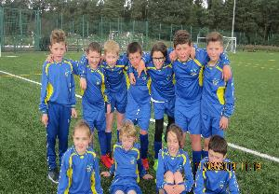
9) Support for Pupils

Getting It Right for Every Child (GIRFEC)
Getting it right for every child is a partnership commitment to ensure that your child has the best possible start in life, based on a shared understanding of their wellbeing. Most of the time, most children get all of the support they need from their families, with help from universal education and health services. When needed, the named person in education can offer help and support to children and families to make sure that the child’s wellbeing is developing and that any issues are being addressed.

If you have any concerns about your child’s wellbeing, you can speak to the named person who will work with you to ensure that your child gets the right help from the right person at the right time. Your school will let you know who this is. It is likely to be the Head Teacher in a primary school and a principal teacher (pupil support) in Secondary.

More information can be found on:
www.girfecinlanarkshire.co.uk and
www.scotland.gov.uk/gettingitright

The programme calls for all workers in health centres and hospitals, nurseries, schools and leisure centres, family centres, social work services and housing offices, and in the community to work together towards changes in culture, systems and practice that will help all children and young people to grow, develop and reach their full potential.

Not all pupils learn at the same pace.

As a result of regular assessment and careful classroom organisation, teachers are able to teach pupils in groups and individually where appropriate. Resources are carefully selected to cater for different ability levels. More able pupils are provided with challenging tasks and extension activities. Less able pupils are given assignments which are within their capabilities to ensure that they experience a sense of achievement, thus encouraging motivation and steady progress.

Sometimes children experience difficulty with a particular aspect of their work.

We try to identify difficulties as soon as possible and give the appropriate support.

The pupil-staff ratio is small and usually it is very apparent when a child is experiencing a problem.
Parents will be notified if the problem persists and some additional home support will be appreciated.

A visiting Support for Learning teacher, Mrs Hazel Leggate, provides support to children who need it and supplements the school’s resources with any that are required for a short period of time. She offers advice to members of staff, carries out assessments and teaches alongside the class teacher.

More serious problems sometimes occur and there may be a need to have a more formal series of assessments carried out by Psychological Services. Parental consent will be sought before this happens and a report will be sent to the parents after the assessment.

Individual learning plans are drawn up for some children and include achievable targets that the child will work towards with the help of the school staff, agencies such a speech/occupational therapists, psychological services and the parents. The parents and child, depending on age, will be asked to contribute to the plan. Plans are reviewed regularly and new targets set.

Enquire is funded by the Scottish Government to provide information on the framework for supporting children who require additional support for learning and to encourage positive partnerships between families, schools and local authorities to ensure children get the right support.

Enquire – the Scottish advice service for additional support for learning

Enquire offers independent, confidential advice and information on additional support for learning through:
Phone Helpline: 0345 123 2303
Address : Enquire
Children in Scotland
Rosebery House
9 Haymarket Terrace
Edinburgh

Advice and information is also available at www.enquire.org.uk Enquire provides a range of clear and easy-to-read guides and fact sheets including The parents’ guide to additional support learning, If you would like to order our leaflets, postcards or guides to share with parents and carers of pupils in your school, please contact us on info@enquire.org.uk learning, If you would like to order our leaflets, postcards or guides to share with parents and carers of pupils in your school,
please contact us on info@enquire.org.uk

Attachment Strategy for Education Resources

Attachment – what we do to support children and young people
South Lanarkshire Council Education Resources is committed to improving outcomes for children and young people by creating emotionally supportive learning experiences in our nurseries and schools.

The Education Resources Attachment Strategy was launched in March 2019 and supports the action in the Getting It Right for Every Child in South Lanarkshire’s Children Services Plan 2017-20 – ‘Develop an attachment strategy and to inform training for staff working with early years to secondary aged children and young people on attachment-informed practice’.

What does it set out to do?
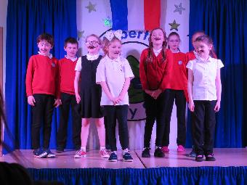
The aim of the strategy is to promote better experiences of attachment for South Lanarkshire’s children and young people and to ensure that all education practitioners understand the importance of attachment and how positive relationships can make a difference to outcomes.

How can I find out more?
South Lanarkshire Council Education Resources have published a series of leaflets and posters for parents/carers which aim to share information on attachment theory and on how this can inform the ways in which we support children and young people.

These are available from schools and we have plans to make them available on-line.
Pupils are challenged and stretched appropriately
Parent

10) School Improvement

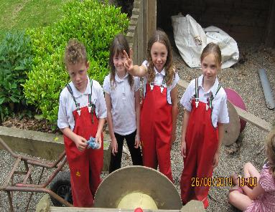
Improvement Priorities 2018-2019

This is an overview of our Improvement Plan Priorities for this session. These are areas we will be developing mainly as a school, some within Biggar Learning Community and others across South Lanarkshire Council.

Priority One: Digital Learning
Priority Two: Health & Wellbeing
Priority Three: Systems Leadership

SOME OF OUR ACHIEVEMENTS AT WISTON PRIMARY THIS YEAR

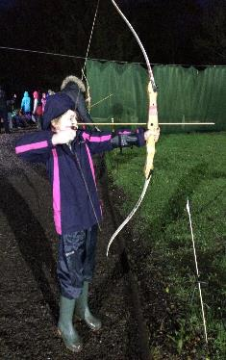

11) School Policies and Practical Information

School Meals
.
Healthy eating is something that the school supports and a range of meals are available at lunchtime that meet the Schools (Health Promotion and Nutrition) (Scotland) Act 2007 and the Nutrient Requirements for Food and Drink in Schools (Scotland) Regulations 2008

The menu consists of a three course meal and all meals include fresh chilled drinking water and milk will be available for those pupils entitled to free school meals through the free school meal eligibility scheme at morning break or lunchtime. Milk is also available for purchase to those pupils wishing to buy at morning break and lunchtime. The children also have access to unlimited bread, salad and vegetables to supplement their meal.

Pupils in:
- Primary 1 - 3 receive a free school lunch.
- Primary 4 - 7 meal cost is £1.70

Please provide your child with a bottle of water each day.

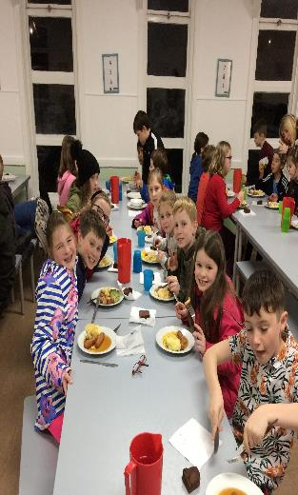
Free School Meals

Children of parents who receive the following benefits are entitled to a free lunchtime meal for their child

- Income Support, Universal Credit (where your take home pay is less than £610 per month), Job Seeker’s Allowance (income based), Employment and Support Allowance (income related), Working Tax Credit and Child Tax Credit (where your gross annual income does not exceed £6,900 as assessed by the HM Revenues and Customs), Child Tax Credit Only (where your gross annual income does not exceed £16,105 as assessed by the HM Revenues and Customs) or receive support under Part VI of the Immigration and Asylum Act 1999.

If you are in receipt of Housing Benefit and/or Council Tax Reduction from us there is no need for you to apply online, we will use the information we hold to automatically award free school meals (P4 to S6) and/or school clothing grants (P1 to S6) to eligible families.

We would encourage parents of children who are in receipt of any of the above benefits to take up this opportunity of having a meal provided for their child when they are at school. Arrangements are in place so that children who receive free meals are not singled out and we encourage all children to remain in school at lunch time.

Allergies

A significant number of children and young people in our schools will have allergies and it is important that parents keep the school fully informed on these matters.

Allergies can present in a variety of ways and can occur at any point in a person’s life. Symptoms range from mild to severe. Children and young people known to have an allergy with moderate to severe symptoms will likely have a Health Care Plan drawn up by the NHS. This will detail symptoms and appropriate interventions.

It is vital that parents share this information with the school and continue to provide any updated information.

Where symptoms are mild and a Health Care Plan is not in place, parents should still continue to liaise regularly with the school on any new triggers, medications and actions required.

In all cases, our employees need to know your child’s symptoms, treatments and any actions required to help prevent exposure to the allergen and minimise the risk of allergic reactions.

Employees in schools will receive training on allergies and will liaise with parents and NHS on any additional specialist training required.

In supporting children and young people with allergies, school employees will operate in accordance with South Lanarkshire Council’s Safe Systems of Work / risk assessment and national guidance on the administration of medicines.

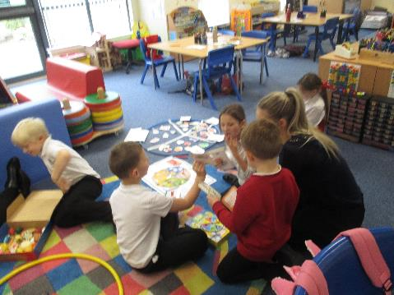
School Uniform
We ask all parents/carers to support the school by encouraging your child(ren) to adhere to the agreed dress code and the wearing of our school uniform. The wearing of a school uniform helps promote the identity of the school in the local community and helps create an ethos of sharing and pride in the school.

In addition, the wearing of a uniform helps towards increasing the protection of all pupils. The wearing of a uniform helps staff and the pupils to distinguish between who belongs to the school and those who may be visitors. This enables staff to approach and identify visitors more readily and helps in trying to offer a safer environment for pupils and teachers alike.

Equality of opportunity is an important aspect of the life of the school. Any proposals on the dress code and on what constitutes the school uniform will be the subject of discussion with the Parent Council and where appropriate consultation with parents, pupils and staff.

There are forms of dress which are unacceptable in all schools such as:

- the wearing of football colours
- clothing with slogans that may cause offence (anti-religious, symbolism or political slogans)
- clothing which advertises alcohol, tobacco or drugs
- clothing which can be deemed unsuitable in terms of health and safety grounds such as shell suits, combat style clothing, dangling earrings, loose fitting clothes particularly in practical classes
- articles of clothing that could be deemed to inflict damage on other pupils or be used by others to do so
- footwear that may damage flooring.

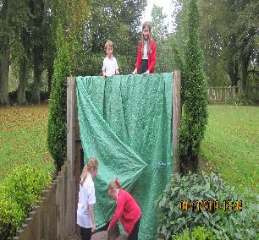

Wiston Primary School uniform:

- Red sweat shirt
- White polo shirt
- Black trousers or black skirt
- White T shirt and black shorts for PE

These can be purchased direct from ALJ Workwear, 35 St. Leonard street Lanark

Support for Parents/ Carers:

Clothing grants/ free school meals
In certain circumstances the Council provides support to parents/carers for the purchase of school wear and free school meals.

We would encourage families, if they are eligible, to apply for these benefits.

Application forms for clothing grant are available from the Council’s website: www.southlanarkshire.gov.uk or from Q and A Offices, Audit and Development 01698 453504/ 453505/453213, the school or Education Resources, Almada Street, Hamilton, phone 0303 123 1023

School Hours

Morning opening 9am
Interval 10.30am – 10.45am
Lunch 12.15pm
Afternoon opening 1.00pm
Close 3.00pm

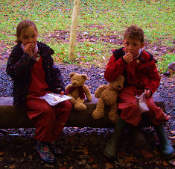
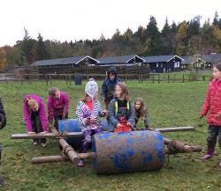
Playground Supervision

There will be an adult in the playground to supervise the children from 8.45 in the morning and during lunchtimes and playtimes.
Holiday Dates

The 2020-2021 School holiday dates are at the back of this document.

Enrolment- how to register your child for school
If your child is starting school for the first time you must enrol your child at their catchment school in January. If parents want their child to go to another school, they must enrol in the first instance with their catchment school and ask for an information leaflet that provides details on how to make a placing request. Forms are available from the SLC website – www.southlanarkshire.gov.uk, schools, Q and A offices or by contacting Education Resources, Almada Street, Hamilton, phone 01698 454102. Completed forms should be returned as soon as possible to Education Resources, Almada Street, Hamilton ML3 0AE.

We would be delighted to welcome visits from parents offered or seeking places for their children. The registration of pupils for Primary 1 in August normally takes place during the second week of January each year. Information will be displayed in local libraries, nurseries and shops. However, if the stated times are not suitable the Head Teacher is available to meet with you at any time.

Please feel free to call the school on 01899 850634 to make an appointment with the Head Teacher

Enrolment date for August 2018 is week commencing 13th January 2020

Transport
South Lanarkshire Council has a policy of providing school transport to primary pupils who live more than one mile by the recognised shortest walking route from their catchment school. This policy is more generous than the law requires. This means that the provision of transport could be reviewed at any time. Parents who consider they are eligible should obtain an application form from the school or Education Resources, Hamilton, phone 0303 123 1023 or web www.southlanarkshire.gov.uk. These forms should be completed and returned before the end of March for those pupils starting the school in August to enable the appropriate arrangements to be made. Applications may be submitted at any time throughout the year and will be considered by Education Resources.

A paid privilege transport scheme is operated for mainstream school contracts where a pupil is not entitled to free school transport. Privilege transport will only be granted providing there is spare capacity on an existing school contract and will be from and to designated pick up and drop off points. Privilege transport will not be provided where a service bus is used on the school run. Any spare capacity will be allocated using agreed priorities. For more information on school transport contact Education Resources phone 0303 123 1023.

Pick-up points

Where school transport is provided it may be necessary for pupils to walk a certain distance to the vehicle pick-up point. Walking distance in total, including the distance from home to the pick-up point and from the drop-off point to the school in any one direction, will not exceed the authority’s distance limit for school transport.

It should be noted that it is the parent’s responsibility to ensure their child behaves in a safe and acceptable manner while travelling in and alighting from the vehicle. Misbehaviour can result in your child losing the right to school transport.

Parents are asked to note that South Lanarkshire Council does not provide transport for those pupils who attend school via a placing request. Where there is a request to place a child under school age in a school within the local catchment area they may receive transport in line with the Council’s transport policy.

Insurance for schools- pupils’ personal effects
South Lanarkshire Council is concerned at the level of claims being received for loss or damage to pupils’ clothing or personal effects. Parents are asked to note the Council’s position in terms of insurance for pupils’ personal effects

(i) Theft/loss of personal effects
The Council is not liable for the loss or theft of pupils’ clothing or personal effects and any items are therefore brought into the school at the pupil/parents’ own risk.

Parents can assist by ensuring that valuable items and unnecessarily expensive items of clothing are not brought to school.

Teachers and other staff have been advised not to accept custody of any such items.

The same principle applies to musical instruments and other equipment used for activities within the school, which belong to the pupil, but are brought into the school. Parents should be aware that if such equipment is left in school, it is done at the pupil/parents’ own risk.

In the case of valuable items such as musical instruments, parents should ensure that these items are covered by their own household insurance.

(ii) Damage to clothing
The Council is only liable for damage caused to pupils’ clothing where the damage has resulted from the negligence of the Council or one of its employees. Claims arising otherwise will not be accepted by the Council’s insurers.

Family Holidays During Term Time
Every effort should be made to ensure that your child attends school during term time. Please contact the school as soon as possible if your child is unable to attend school.
Family holidays should be avoided during term time as this both disrupts the child’s education and reduces learning time. If holidays are taken during times when the school is open parents should inform the school in advance by letter.

If your child is taken on a family holiday during term time then in line with Scottish Government advice this will be classified as an unauthorised absence. However, in exceptional circumstances schools may register a family holiday during term time as an authorised absence when for example, parents are unable to obtain leave during the school holiday period.

Clearly, absence with no explanation from parents will mean that the absence will be recorded as unauthorised. In our approach to raising attainment and achievement it is recognised that attendance at school is something that should be continuously encouraged. Parents/carers, children and the school all have a part to play in encouraging and stressing the importance of attendance at school.

The school dates for 2019-2020 are at the back of this handbook. In addition, the school holiday dates and in-service dates are available from the website www.southlanarkshire.gov.uk
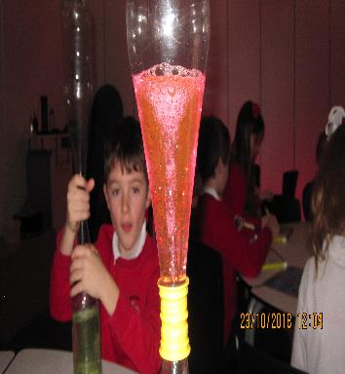
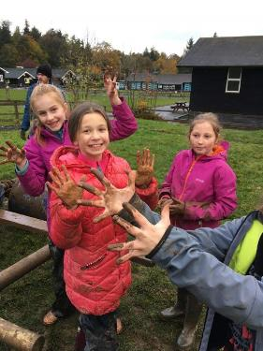

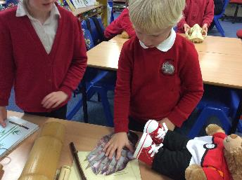
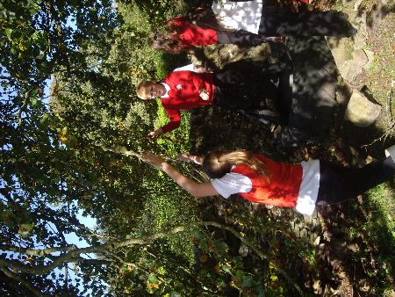
Challenges!
Promoting Positive Behaviour
It is the responsibility of staff within the school to ensure that parent council members, parents and pupils are involved in the creation of a positive school ethos that encourages good behaviour. Equally, the school whilst trying to promote positive behaviour must support young people should incidents or bullying occur. Parents have a significant role to play in working with the school so that teachers, parents and pupils know what is expected of them in trying to change the behaviour and attitudes that contribute to bullying behaviour.

Our approach is to create an environment where better behaviour will encourage better learning. The school, along with the support of parents, can work together to create a learning environment which young people can enjoy and feel safe.

Incidents of bullying should be reported to the school immediately so that each alleged incident can be looked at. Together we can work towards creating a safer school for children and staff.

In addition, a guideline (Promoting Positive Relationships and Behaviour) has been produced to support all teaching and support staff and inform them of their roles and responsibilities in respect of dealing with the small number of children and young people who display challenging behaviour. Early identification is crucial so that intervention can be provided to support children and young people to help them address their issues and concerns. Staff training is provided to help develop the skills needed to respond to and manage challenging behaviour. A wide range of appropriate staff development opportunities has been developed for this purpose.

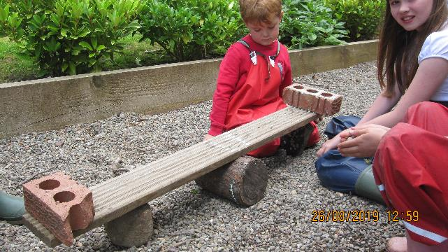

Child Protection
All staff in educational establishments in South Lanarkshire Council are required to receive an annual update and follow the advice and guidance contained within the Education Operating Procedures. All staff must also complete a Learn on Line Course “Child Protection in Education.

The shared vision for Lanarkshire’s children is: “all children and young people in Lanarkshire have the right to be cared for and protected from abuse and harm in a safe environment in which their rights are respected.” All agencies will work together in a collaborative way to promote the safety and wellbeing of children and young people in Lanarkshire.

The Chief Officers and Child Protection Committees of North and South Lanarkshire Council’s are the driving force for ensuring that agencies individually and collectively work to protect children and young people as effectively as possible.
The Council has a duty in law to report suspicions that a child has been abused or is at risk of harm, in terms of the Children (Scotland) Act 1995. Therefore, Council staff have a professional and contractual obligation to report concerns to the Head of Establishment or the Child Protection Co-ordinator immediately.

Education Resources staff and visitors from other agencies and services are required to follow these Child Protection Procedures to protect and support children and to fulfil their professional obligations to report all allegations or suspicions of child abuse.

For more information, or if you have a concern of a child protection nature, please contact the head of the educational establishment which your child attends.

Keeping safe online
The Council has produced an information leaflet – ‘stay safe’ for parents/carers on how to help ensure their child is safe when using the internet and mobile devices.
Copies are available from the school or the web: www.southlanarkshire.gov.uk

Information on Emergencies
We make every effort to ensure the school remains open during term-time for pupils. However, on occasions circumstances may arise which can affect the school. Schools may be affected by, for example, severe weather, power failures or through any other circumstances that may impact on the school day. In such cases we shall do all we can to let you know if this happens. We shall keep you in touch by phone, text, where appropriate, letters, web news and through local radio stations particularly if there are prolonged periods of severe weather. The Council’s website www.southlanarkshire.gov.uk will be used to let you know if the school is closed and when it will re-open.

It is important for parents/carers to let the school know of any change to your mobile/home phone number and change of address.

If for any reason, you are unsure if the school is open, please contact the school or Education Resources, Operations Service, Almada Street, Hamilton or email us at: education@southlanarkshire.gov.uk or visit the website www.southlanarkshire.gov.uk

Your Commitments
We ask that you:
- support and encourage your child’s learning
- respect and adhere to the schools policies and guidance
- let the school know if you change your mobile/phone number and/or address
- enjoy and take part in school activities
- accept your responsibility to respect staff who work in the school and for the school to be proactive in taking forward it’s commitment to care for and educate your child

General Data Protection Regulation as supplemented by the Data Protection Act 2018 (GDPR)

Information on pupils, parents and guardians is held by the school to enable the teaching, registration and assessment of pupils as well as associated administrative duties. The information is stored and used as per the requirements of the GDPR, with South Lanarkshire Council defined as the data controller. The Council have established a data protection policy that applies to all of its school.
Education Resources has also prepared a privacy notice (below) which sets out how we will deal with personal information as part of our statutory function as an education authority. For more information please contact the school.

Privacy Notice

Introduction
The Council has a legal obligation to deliver effective education services to children, young people and adult learners in South Lanarkshire. In order to do this we need to collect personal information about children, young people and their families so that we can help them to learn and keep them safe.

Using your personal information
The Council is a “controller” of the personal information you provide when enrolling for a nursery or school, applying for an education service or participating in groups or activities provided by Education Resources.

Information we collect from you about you and your child at enrolment
When you enrol for a nursery or school, we ask for the following information:
- parent/carer contact details (name, address, phone, email);
- the child’s name, date of birth, gender and address;
- information about medical conditions, additional support needs, religion and ethnicity;
- any information you may wish to provide about family circumstances.

Information we collect at other times
We will also collect information at other times such as when you apply for a benefit, request a services or other support. We will provide an additional privacy notice at these times.
- When you apply for an education service or benefit, such as school transport, free school meals, clothing grant, placing request or EMA, we will also ask for personal information as set out above. We will also ask for information about your income for education benefits applications.

- If you make a request for additional support such as an educational psychologist or other support for learning we will ask for more detailed information to allow us to provide the most appropriate support for your family. This may include information about family circumstances or medical conditions.

- If you wish to participate in activities or support for young people through our youth centres, or through adult learning programmes within the community, we will also ask for your personal information to support your application. This may include information about family circumstances or medical conditions.

We require this information to ensure that children and young people are educated appropriately, supported, and that we take account of their health and wellbeing. We will also ask you to update this information annually and to tell us when there are changes to your details.

Information that we collect from other sources
As an education authority and as part of our statutory function in accordance with our legal obligations, we receive information from other sources such as the SQA, the NHS or Social Work about you or your child, this includes:
- exam results and assessment information;
- information about health, wellbeing or child protection.

Why do we need this information?
We need this information so the Council can ensure it is delivering education services appropriately to all learners:
- for the education of children, young people and adult learners;
- for teaching, enrolment and assessment purposes and to monitor the educational progress of children, young people and adult learners ;
- to keep children and young people safe and provide guidance services in school;
- to identify where additional support is needed to help children, young people and adult learners with their learning;
- to maintain records of attendance, absence and behaviour of children and young people (including exclusions);
- to support children and young people moving on each year from nursery to primary, primary to secondary and when they move or leave school;
- to help us develop and improve education services provided for young people, adult learners or families
- In accordance with our legitimate interests as an education authority we will also use your information to create statistical reports.

We will share your information with:
As an education authority and as part of our statutory function in accordance with our legal obligations we will share information with other bodies or parts of the Council, including:
- The Scottish Government and bodies such as Education Scotland, Scottish Qualifications Authority, Skills Development Scotland and other organisations that support children and young people’s learning;
- Other parts of the Council when required for services such as school meals, school transport, education benefits and with Social work in connection with any child protection concerns we become aware of;
- South Lanarkshire Leisure and Culture Limited, where children and young people are participating in sports and leisure activities;
- Other schools/local authorities – if a child moves or transfers to another school the Council has an obligation to pass on information with regards to pupil records to the new school/local authority.

You have the right to access your personal information as well as the rights of rectification, erasure, restriction and the right to object. For information on these rights and how to exercise them or for information about how we manage your personal information, you can get a copy of our full privacy notice from our website: (https://www.southlanarkshire.gov.uk/info/200235/meta/1730/general_privacy).

Our full privacy notice will also provide information on how to make a complaint or to request a paper copy of the privacy notice from the Data Protection Officer.

USEFUL LINKS

Choosing a School: A Guide for Parents - information on choosing a school and the placing request system – http://www.scotland.gov.uk/Publications/2010/11/10093528/0

A guide for parents about school attendance explains parental responsibilities with regard to children’s attendance at school – http://www.scotland.gov.uk/Publications/2009/12/04134640/0

Parental involvement
Guidance on the Scottish Schools (Parental Involvement) Act 2006 provides guidance on the act for education authorities, Parent Councils and others – http://www.scotland.gov.uk/Publications/2006/09/08094112/0

Parentzone provide information and resource for parents and Parent Councils – http://www.educationscotland.gov.uk/parentzone/index.asp

School ethos
Health and wellbeing guidance on healthy living for local authorities and schools –http://www.scotland.gov.uk/Topics/Education/Schools/HLivi

Building Curriculum for Excellence Through Positive Behaviour and Relationships outlines the Scottish Government’s priority actions around positive behaviour in schools and is also a source of support – http://www.scotland.gov.uk/Publications/2010/06/25112828/0

Curriculum
Information about how the curriculum is structured and curriculum planning – http://www.educationscotland.gov.uk/thecurriculum/

Information about the outcomes a learner can expect to experience and achieve across literacy, numeracy and health and wellbeing, as well as the 8 curricular areas –
http://www.educationscotland.gov.uk/thecurriculum/howisthecurriculumorganised/experiencesandoutcomes/index.asp

Advice, practice and resources to support the experiences and outcomes on literary, numeracy and health and wellbeing – http://www.educationscotland.gov.uk/learningteachingandassessment/learningacrossthecurriculum/responsibilityofall/index.asp

Broad General Education in the Secondary School – A Guide for Parents and Carers – http://www.educationscotland.gov.uk/Images/CfEbriefingforparentsfinal_tcm4-725662.pdf

Information on the Senior Phase – http://www.educationscotland.gov.uk/thecurriculum/whatcanlearnersexpect/seniorphase.asp

Information on Skills for learning, life and work –
http://www.educationscotland.gov.uk/thecurriculum/whatcanlearnersexpect/skillsforlearning.asp

Information for organisations responsible for the planning, management and delivery of career information, advice and guidance services – http://www.skillsdevelopmentscotland.co.uk/our-story/key-publications/career-management-skills-framework.aspx

The Skills Development Scotland website ‘My World of Work’ offers a number of tools to support career planning – http://www.skillsdevelopmentscotland.co.uk/
Assessment and reporting
Information about Curriculum for Excellence levels and how progress is assessed –
http://www.educationscotland.gov.uk/thecurriculum/howisprogressassessed/stages/index.asp

Curriculum for Excellence fact file - Assessment and qualifications – http://www.educationscotland.gov.uk/publications/c/publication_tcm4624968.asp

Information on recognising achievement, reporting and profiling –
http://www.educationscotland.gov.uk/learningteachingandassessment/assessment/achievement/index.asp

Transitions
Choices and changes provides information about choices made at various stages of learning – http://www.educationscotland.gov.uk/supportinglearners/choicesandchanges/index.asp

The Additional support for learning page provides links to relevant legislation and guidance, including the arrangements that should be in place to support pupils with additional support needs – http://www.scotland.gov.uk/Topics/Education/Schools/welfare/ASL

Enquire is the Scottish advice service for additional support for learning – http://enquire.org.uk/

Parenting Across Scotland offers support to children and families in Scotland – http://www.parentingacrossscotland.org/

Support for pupils
Information about the universal entitlement to support that underpins Curriculum for Excellence –
http://www.educationscotland.gov.uk/inclusionandequalities/supportingchildrenandyoungpeople/whatissupport/universalsupport/roleofkeyadult.asp

Getting It Right For Every Child and Young Person, is essential reading for anyone involved or working with children and young people, including practitioners working in adult services with parents and carers – http://www.scotland.gov.uk/Topics/People/Young-People/gettingitright
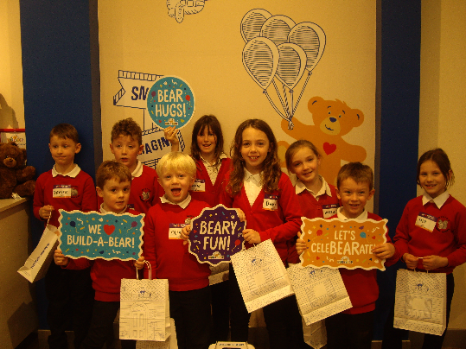

Education Resources

School holiday Dates Session 2019/2020
Break | Holiday dates
First Term | Teachers In-service | Tuesday | 13 August 2019
 | In-service day | Wednesday | 14 August 2019
 | Pupils return | Thursday | 15 August 2019
September Weekend | Close on  Re-open | Thursday  Tuesday | 26 September 2019  1 October 2019
October Break | Close on  Re-open | Friday  Monday | 11 October 2019  21 October 2019
 | In-service day | Monday | 18 November 2019
 | In-service day | Tuesday | 19 November 2019
Christmas | Close on  Re-open | Friday  Monday | 20 December 2019  6 January 2020
Second Term
 | In-Services day | Friday | 7 February 2020
February break | Closed on | Monday and  Tuesday | 10 February 2020  11 February 2020
 | In-service day | Wednesday | 12 February 2020
Spring break/Easter | Close on  Re-open | Friday  Monday | 3 April 2020  20 April 2020
Third Term
 | In-service day | Thursday | 7 May 2020
Local Holiday | Closed | Friday | 8 May 2020
Local Holiday | Close on  Re-open | Thursday  Tuesday | 21 May 2020  26 May 2020
Summer break | Close on | Wednesday | 24 June 2020
Proposed in-service  days | Tuesday 11 August 2020 and Wednesday 12 August 2020  Pupils return Thursday 13 August 2020

Notes
- Good Friday falls on Friday, 10 April 2020

- Lanark schools will close Thursday, 11 June 2020 and Friday, 12 June 2020

- Schools will close at 2.30pm on the last day of terms 1 and 2
(Friday, 20 December 2019 and Friday, 3 April 2020)

- Schools will close at 1pm on the last day of term 3 Wednesday, 24 June 2020

Education Resources

School holiday Dates Session 2020/2021
Break | Holiday dates
First Term | Teachers In-service | Tuesday | 11 August 2020
 | In-service day | Wednesday | 12 August 2020
 | Pupils return | Thursday | 13 August 2020
September Weekend | Close on  Re-open | Thursday  Tuesday | 24 September 2020  29 September 2020
October Break | Close on  Re-open | Friday  Monday | 09 October 2020  19 October 2020
 | In-service day | Monday | 16 November 2020
Christmas | Close on  Re-open | Tuesday  Wednesday | 22 December 2020  6 January 2021
Second Term
February break | Close on  Closed on | Friday  Monday and  Tuesday | 5 February 2021  8 February 2021  9 February 2021
 | In-service day | Wednesday | 10 February 2021
Spring break/Easter | Close on  Re-open | Thursday  Monday | 1 April 2021  19 April 2021
Third Term
Local Holiday | Closed | Monday | 3 May 2021
 | In-service day | Thursday | 6 May 2021
Local Holiday | Close on  Re-open | Thursday  Tuesday | 27 May 2021  1 June 2021
Summer break | Close on | Thursday | 24 June 2021
Proposed in-service  days | Tuesday 10 and Wednesday 11 August 2021  Pupils return Thursday 12 August 2021

Notes
- Good Friday falls on Friday, 2 April 2021

- Lanark schools will close Thursday, 10 June 2021 and Friday, 11 June 2021

- Schools will close at 2.30pm on the last day of terms 1 and 2
(Tuesday, 22 December 2020 and Thursday, 1 April 2021)

- Schools will close at 1pm on the last day of term 3 Thursday, 24 June 2021.

